

**MOBILE APPLICATION DEVELOPMENT SSE3151**

**SEM 1 2020/2021**

**INCEPTION PHASE**

**for**

**HOUSEHOLD INVENTORY**

**Prepared by:**

Nur Hazimah Binti Hamdan 198919

Nur’Adila Syarmila Binti Rasid  199002

Due Date: 3rd January 2021

Table of Contents

1 Problem Statement 3

2 General Concept 3

2.1 User Classes and Characteristics 3

2.2 Use Case 4

2.3 Functional Requirements 4

2.3.1 Login 4

2.3.2 Manage Item 5

2.3.3 Update Stock 5

2.3.4 Share Inventory 6

3 Frontend Features 7

3.1 Design Interface 7

3.1.1 Login 7

3.1.2 Manage Item 8

3.1.3 Update Stock 9

3.1.4 Share Inventory 10

3.2 Wireframe Interface 11

4 Backend Features 11

4.1 Database Management 11

Framework 11

4.2 Languages 12

5 Commercialize Value 12

5.1 Unique features 12

5.2 Target market 12

5.3 Market price 12

# Problem Statement

The world that we live in today provides a constant supply of information for us to process and the volume of this has been growing at an alarming rate over the past several years. It has been improving as the technology and IT is actively growing throughout the years. However, a great pandemic is happening since January 2020 until now and it been very hard to people as government encourage the people to not freely go out from the house. During the pandemic, the whole country was lockdown and only 1 people in the house can go out to buy the needs. Therefore, we propose a solution to this issue by developing software that keeps track of inventory in the “back of house”, or kitchen. These changes in inventory are kept track of through utilizing a database.

# General Concept

Household Inventory application is created to keep up to date with the stock in the house. People can keep track all the needs before they restock which makes it more convenient. However, there are existing applications that have same concept with Household Inventory but slightly different which are the fingerprint and dark or light themes. We decide to make it more secure applications with fingerprints and make it more convenient when using it in the dark or light. It will allow user to sign in via the existing email. Moreover, it does not involve any payments as it just inventory applications. The suitable platform for Household Inventory application is Android.

## User Classes and Characteristics

The user class involved only Users. The users who 5++ age can use the application. Users can sign up to register with their own email so that it can be more secure. User also can manage the stock by creating, editing, and deleting the stocks. Moreover, user also can update the list stocks and share the inventory list with other users.

## Use Case

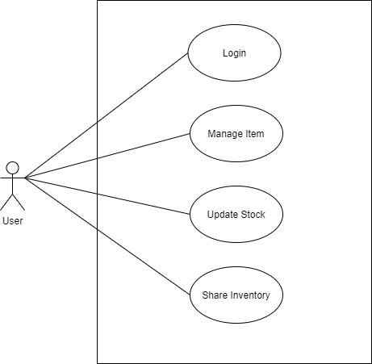

## Functional Requirements

### Login

|  |  |
| --- | --- |
| Brief description | The use case begins when the actor types his/her name and password on the login form. |
| Basic flow | 1. The system validates the actor’s password and logs him/her into the system. 2. The system displays the Home page, and the use case ends. |
| Alternative flow | 1. Invalid Name / Password   If in the basic flow the system cannot find the name or the password is invalid, an error message is displayed. The actor can type in a new name or password or choose to cancel the operation, at which point the use case ends. |
| Preconditions | User needs to have an account registered to the system |
| Postconditions | There are no postconditions associated with this use case. |

### Manage Item

|  |  |
| --- | --- |
| Brief description | User can create new item to the list, edit existing item and delete existing item from the list. |
| Basic flow | **Create Stock**   1. System display all the items. 2. User click add button at the bottom page. 3. User fills in details of the stock. 4. Users click on Add Item button and stock successfully added.   **Edit Stock**   1. System display all the items. 2. Users click on selected item. 3. User choose edit option. 4. Users edit the details that need to be updated. 5. Users click on confirm button.   **Delete Stock**   1. System display all the items. 2. Users click on selected item. 3. Users choose on delete option. 4. Users click on delete button. |
| Alternative flow | There are no alternative flows associated with this use case. |
| Preconditions | Successfully login into the system. |
| Postconditions | There are no postconditions associated with this use case |

### Update Stock

|  |  |
| --- | --- |
| Brief description | User can update the selected stock either to restock or destock |
| Basic flow | 1. System display all the items. 2. Users click on add button or minus button on the selected stock to update the stock. Users enter the number for restock or destock 3. Users click on confirm button. |
| Alternative flow | There are no alternative flows associated with this use case. |
| Preconditions | There are items in the list. The items in the list is not null. |
| Postconditions | There are no postconditions associated with this use case. |

### Share Inventory

|  |  |
| --- | --- |
| Brief description | User can choose to share the inventory with the family or friends to let them update or modify items. |
| Basic flow | 1. Users go to setting page. 2. Users click on Share Inventory section. 3. Users enter the existed email that have been registered to the system. |
| Alternative flow | There are no alternative flows associated with this use case. |
| Preconditions | There are no preconditions associated with this use case. |
| Postconditions | There are no postconditions associated with this use case. |

# Frontend Features

## Design Interface

### Login

1. Login Page

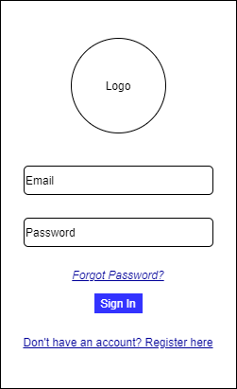

1. Signup Page

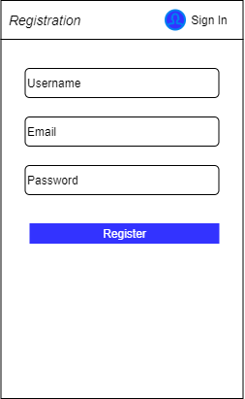

### Manage Item

1. Add Item

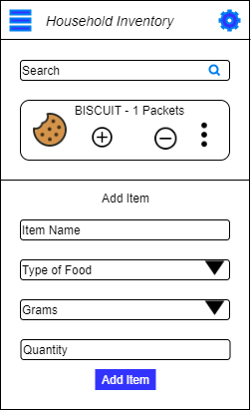

1. Edit Item

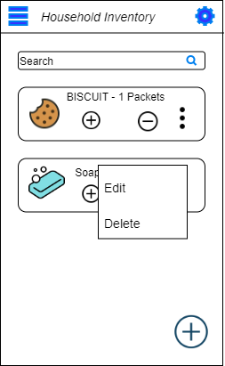

1. Delete Item

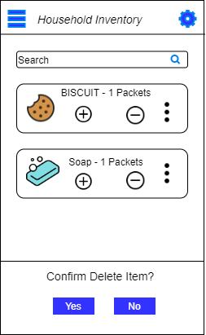

Update **Stock**

1. Restock

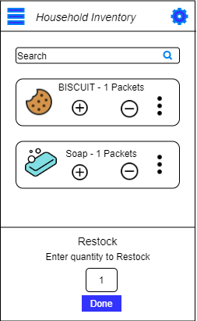

1. Destock

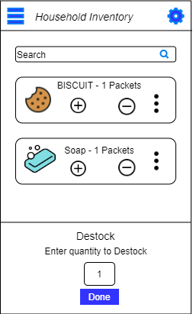

### Share Inventory

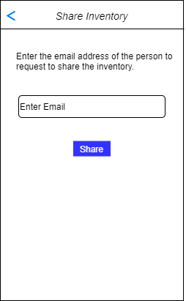

## Wireframe Interface

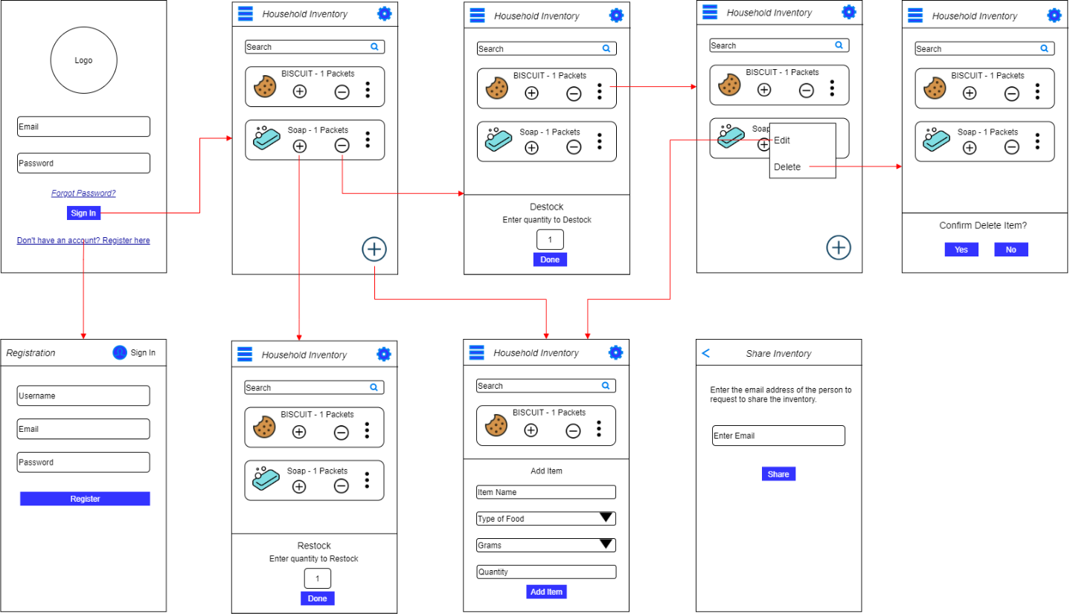

# Backend Features

## Database Management

1. Firebase

Firebase is a platform developed by Google for creating mobile and web applications. Firebase consists of many products including the database. Household Inventory will be using Cloud Firestore to store the user data.

## Framework

1. Flutter

This is Google’s free & open-source mobile UI SDK framework for building apps in a unique approach compared to other frameworks. Considered best for hybrid app development, it uses a single codebase and allows developers to test, perform UI, unit and functionality tests without encountering errors. Its hot reloaded feature is used for continuous testing without the need for restarting an application.

## Languages

1. Dart

Dart is an open source, purely object-oriented, optionally typed, and a class-based language which has excellent support for functional as well as reactive programming.

# Commercialize Value

## Unique features

Our system uses biometric sensor such as fingerprint to unlock the system. Besides, our system also has features that enable dark theme for anyone with dazzled problem. Our system provides an interactive interface. It is a user-friendly for older generation and young generation. Our system also provides features that can share the inventory among family members of friends and can easily updated whenever and wherever.

## Target market

Our target market is open to community of people that live in the house whether with family, friends, with housemaid, or without housemaid. The creation of the system is to help house members to keep track with household in the house. Especially during lockdown, our system is on demand because of only one representative member of the house can go out to buy a household for family. They can keep track which items that need to be restock from the system and can update to house members that shared the inventory in the system.

## Market price

Our commercialize plan is to give 30 days free trial to anyone who registered and to continue, they need to pay RM14.90 for the application.